Chapter 16, Solution 52.

If the switch in Fig. 16.75 has been closed for a long time before t = 0 but is opened at t = 0, determine i_{x} and v_{R} for t > 0.

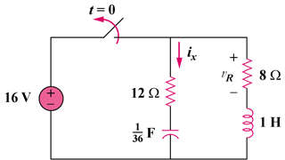

Figure 16.75
For Prob. 16.52.

Solution

Step 1. Fist we need to determine the initial conditions. Just before the switch opens, v_{C}(0) = 16 volts and i_{L}(0) = 2 amps. Next we convert the circuit into the s-domain.

12 Ω
16/s

+
−
36/s
I_{x}

s

2/s

8 Ω

+
V_{R}
–

We can now write a mesh equation (this time going in the counter-clockwise direction). [s(I_{x}+2/s)]+[8I_{x}]+[12I_{x}]+[(36/s)I_{x}]+(16/s) = 0 and V_{R} = –8I_{x}.

Step 2. [s+8+12+(36/s)]I_{x} = [(s²+20s+36)/s]I_{x} = –2–16/s = –[2(s+8)/s] or
I_{x} = –2(s+8)/[(s+2)(s+18)] = [A/(s+2)]+[B/(s+18)] where
A = –2(–2+8)/(–2+18) = –2x6/16 = –0.75 and B = –2(–18+8)/(–18+2) = –1.25 thus,
i_{x}(t) = [–0.75e^{–2t}–1.25e^{–18t}]u(t) amps and
v_{R}(t) = –8i_{x}(t) = [6e^{–2t}+10e^{–18t}]u(t) volts.

